Project Documentation

# 1. Introduction

This project implements a futuristic city scene using Three.js. It includes buildings, roads, trees, cars, and drones with animations. The scene showcases advanced 3D graphics techniques such as texture mapping, environment mapping, bump mapping, and shading.

# 2. Proof of Execution

Screenshots of the running application (at the end) showing:  
- The city scene rendering with buildings and vehicles.  
- Animated cars rotating and moving.  
- Hovering and moving drones.  
- Different camera views, including top-down and orbit controls.  
  
The project compiles and runs successfully in a web browser supporting WebGL (tested in Edge). All models load, animate, and respond to input controls."

# 3. Features Implemented

## 3.1 Texture Mapping

- Applied texture maps on building surfaces, including walls and windows, using image files loaded with Three.js TextureLoader.  
- Grass and pavement surfaces also use repeating textures.

## 3.2 Environment Mapping

- Added environment mapping to buildings by applying a cubemap texture that reflects the surrounding environment.  
- This gives buildings reflective surfaces, enhancing realism and the sci-fi atmosphere.

## 3.3 Normal (Bump) Mapping

- Applied normal maps to building surfaces to simulate detailed surface textures without increasing polygon count.  
- Normal maps were created or sourced externally and loaded as additional textures.  
- Normal maps affect lighting calculations to produce fine bumps and grooves.

# 4. Shading Types Used

- Flat Shading: Used minimally or for simple geometric shapes (if any).  
- Gouraud Shading: Not directly implemented (Three.js uses physically based rendering by default).  
- Phong Shading / Physically Based Rendering (PBR): Employed using MeshStandardMaterial for buildings, vehicles, and environment, allowing realistic light reflections and surface detail.

# 5. Camera Controls

- Orbit Controls: Allows the user to rotate around the scene, zoom, and pan using mouse input.  
- Keyboard Controls:  
 - Arrow keys to move the camera position forward/backward and sideways.  
 - Shift key for boosted movement speed.  
 - Pressing 'v' toggles between the normal orbit view and a fixed top-down view.  
- These controls allow exploring the city scene interactively.

# 6. Known Issues / Limitations

- Shadows are currently disabled due to performance or complexity.  
- Some buildings use a single normal map for all faces rather than unique ones, which may reduce realism.  
- Environment map uses a static cube texture; dynamic reflections are not implemented.  
- Flat shading or Gouraud shading are not explicitly programmed but can be further explored.  
- Model loading relies on external GLTF files; failure to load models results in missing objects.

# 7. How to Run the Project

- Host the files on a local or remote web server (e.g., using live-server or similar).  
- Open the main HTML/JS file in a WebGL-capable browser.  
- Use mouse and keyboard controls as described to explore the scene.

# 8. References

**Used free resources from:**

https://polyhaven.com/  
<https://www.turbosquid.com/>

#### Top View

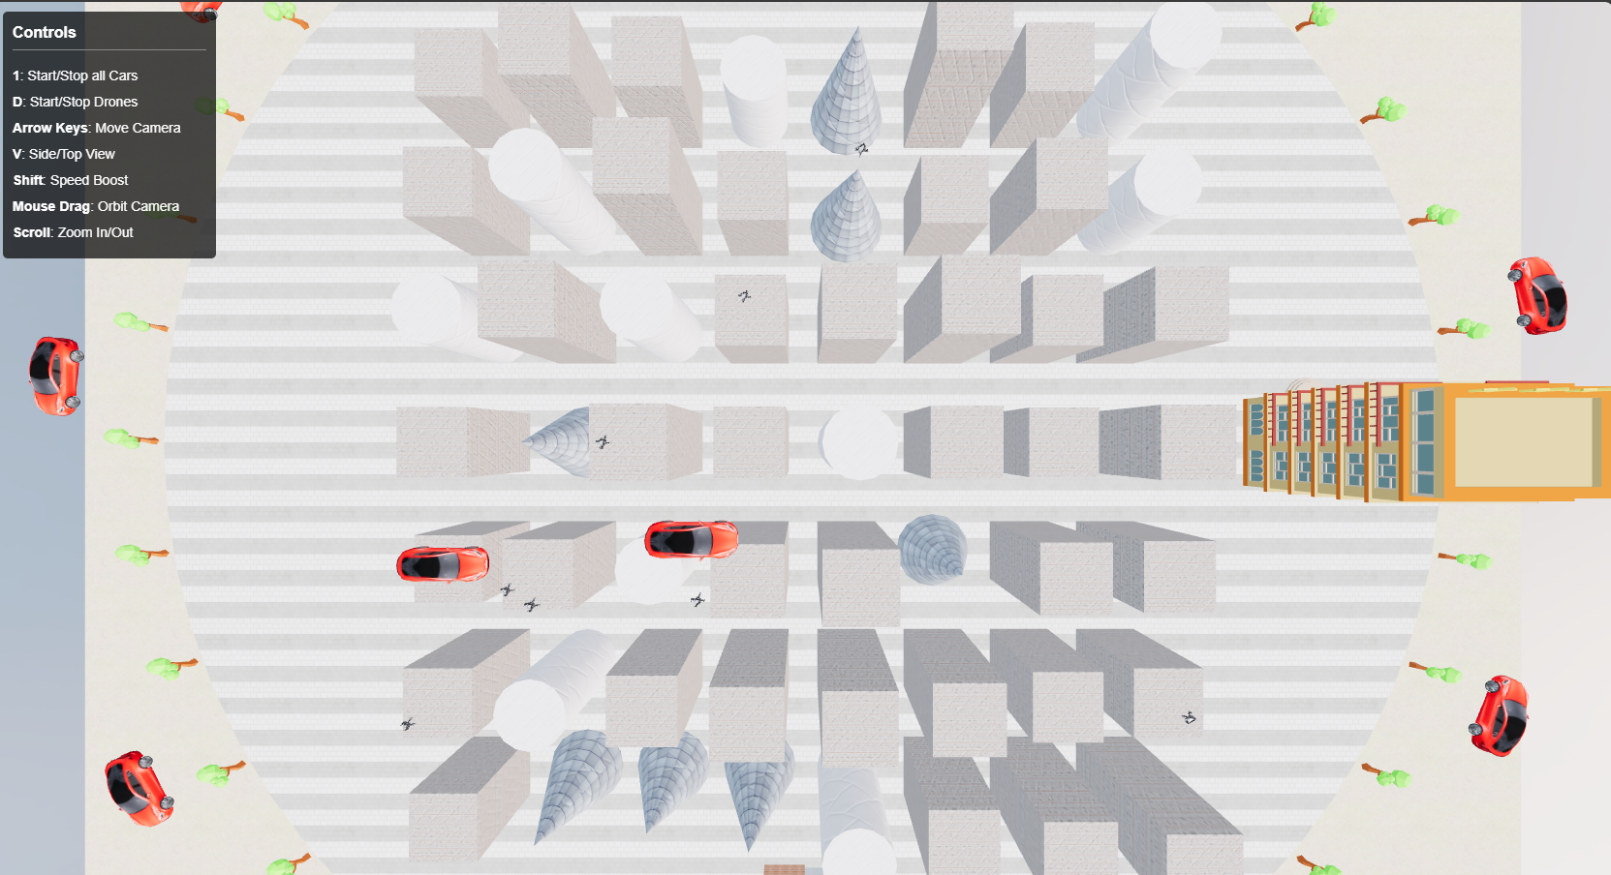

#### Side View

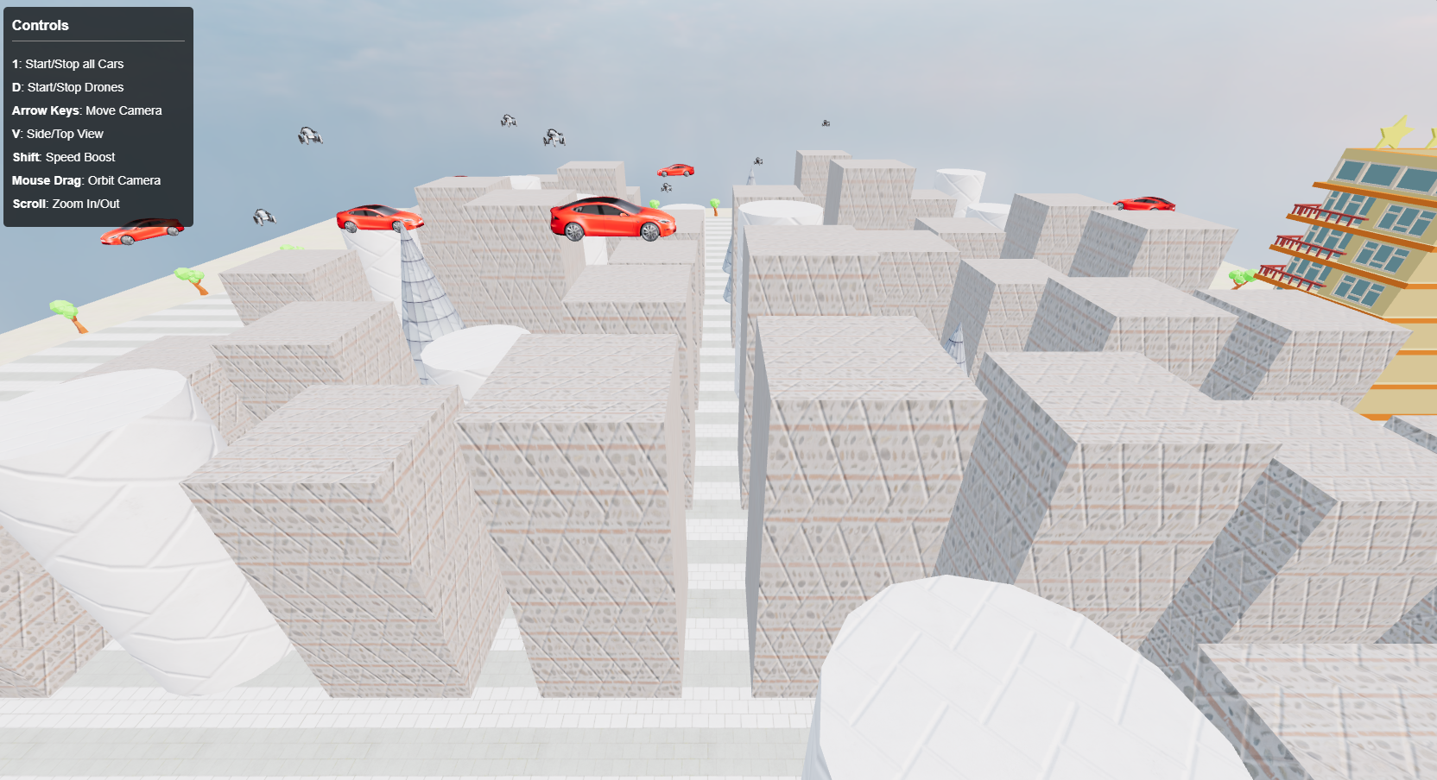

#### Movement Stop/Start

The following images show the cars and drones in different positions to highlight that they can be stopped and started

